1st Grade Supply List

Box of yellow #2 pencils
2 Boxes of 24 crayons
Color pencils
Markers
Erasers (big pink ones)
Scissors
Ruler (inches/centimeters)
2 Pencil boxes (no zipper pouches please) 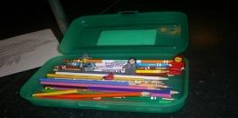
This Photo by Unknown Author is licensed under CC BY-SA
Glue sticks
2 reams copy paper
Box of tissues
Hand sanitizer
Clorox wipes

Please write student’s name on color pencils, markers, rulers, and scissors. Leave all supplies unopened including pencils and erasers. Space is very limited please send only the supplies listed. Please do not send zipper pouches, toy erasers, lead pencils, or personal pencil sharpeners.

